Planet Brochure Directions
Use the brochure program found in Microsoft Publisher
Choose an information brochure. I am using eclipse to demonstrate.
Use the right panel of page 1 as your Title Page. Your Title Page will include your planet name and a picture of your planet. Your name, hour and due date will be at the bottom. The rest of the panels on page 1 might not be used.
Delete text boxes you do not need.
The left panel may be needed to complete the questions.
Brochure page numbers are found at the bottom of the brochure page.
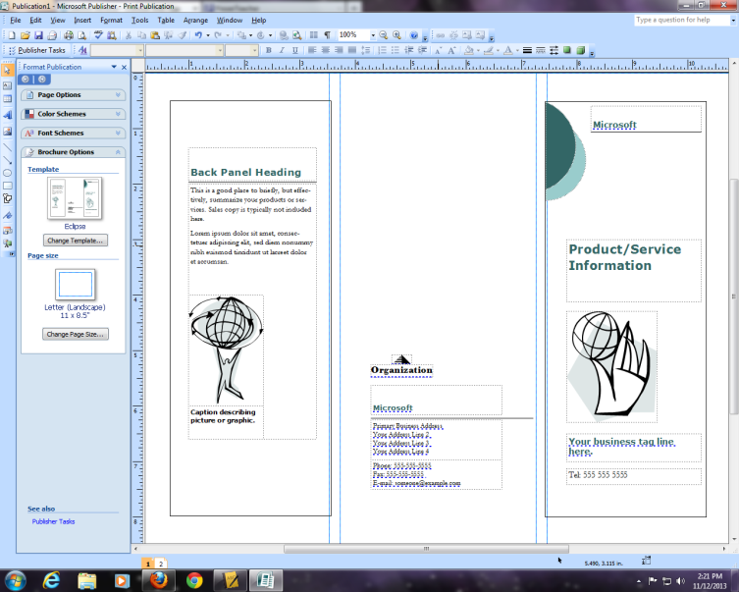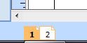 Notice the 1 is highlighted
Delete the left and center panel text and picture boxes
Brochure page 1

Use page 2 of the brochure to answer all of your questions.
Number each question. You may write the question and answer it or write in complete sentences.
Skip a line between each question
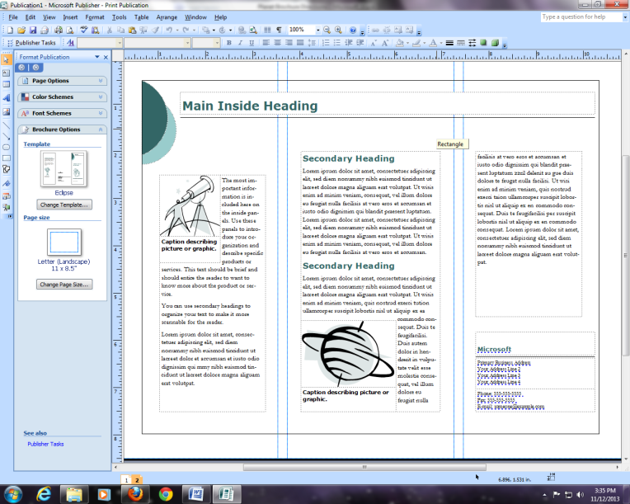 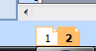Notice the 2 is highlighted
Click on the text and highlight to delete the text.
Use the picture boxes to include your pictures
Printing
- You will print one page at a time
- Open page 1
- File>print
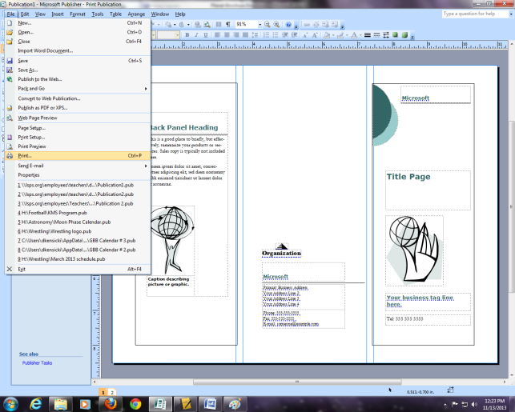
- Current page>print
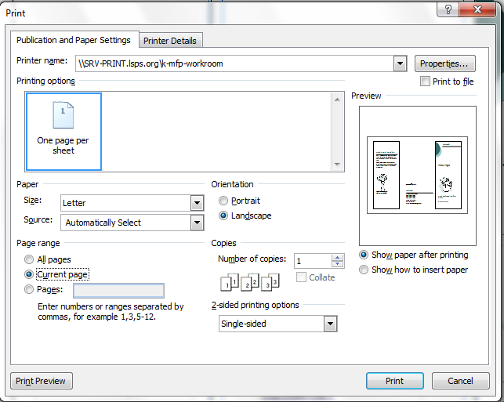
- After page 1 prints, place page 1 back into the printer with page 1 side up and title towards the back.
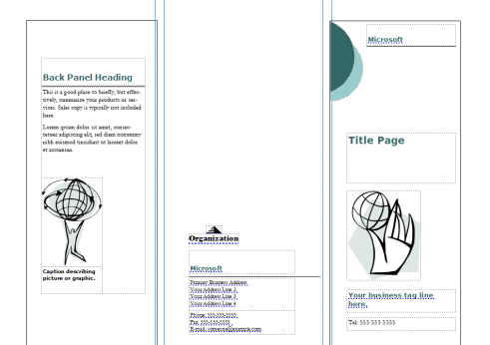
Place the right panel to the back of the printer
- Open page 2 and follow the above procedure for printing
